
A Cultural resources survey of the proposed expansion of the diablo sand and gravel pit, Pinal County, arizona
FORT BLISS ROCK ART PIGMENT ANALYSIS
BRUKER TRACER III-V EDXRF STUDY OF PICTOGRAPHS AT WHITE ROCK SHELTER AND PICTURE CAVE

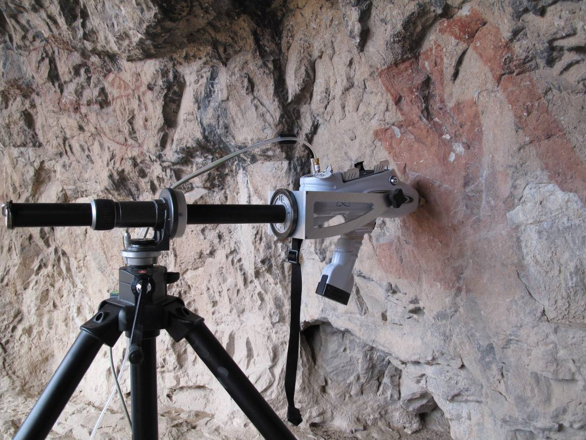

By Wesley D. Miles and M. Scott Thompson
By

Chris Loendorf

Contributions by

Craig Fertelmes

pXRF Analysis Report 2011-01

Material Science Laboratory
Gila River Indian Community
Cultural Resource Management Program
Sacaton, Arizona
2011
FORT BLISS ROCK ART PIGMENT ANALYSIS:
BRUKER TRACER III-V EDXRF STUDY OF PICTOGRAPHS AT WHITE ROCK SHELTER AND PICTURE CAVE

by

Chris Loendorf

Contributions by

Craig Fertelmes

Material Sciences Laboratory
Gila River Indian Community
Cultural Resource Management Program

pXRF Analysis Report 2011-01

2011

table of contents

INTRODUCTION 3

METHODOLOGY 3
COMPOSITIONAL ANALYSIS OF PIGMENTS 3
DATA COLLECTION PROCEDURES 3
Data Analysis 3

RESULTS 3
PICTURE CAVE ROCK FILTER DATA 3
PICTURE CAVE TI FILTER DATA 3
WHITE ROCK SHELTER ROCK FILTER DATA 3
WHITE ROCK SHELTER TI FILTER DATA 3

CONCLUSIONS 3

REFERENCES 3

LIST OF FIGURES

Figure 1. EDXRF data collection from Element BB at Picture Cave, Fort Bliss.

Figure 2. Pictograph Panel 2 at White Rock Shelter, Fort Bliss.

Figure 3. Boxplots of arsenic X-ray pluses per analysis time (150 seconds) for control and pigmented locations at Picture Cave, 40KeV with rock filter.

Figure 4. Boxplots of iron X-ray pluses per analysis time (150 seconds) for control and pigmented locations at Picture Cave, 40KeV with rock filter.

Figure 5. Boxplots of copper X-ray pluses per analysis time (150 seconds) for control and pigmented locations at Picture Cave, 40KeV with rock filter.

Figure 6. Boxplots of zinc X-ray pluses per analysis time (150 seconds) for control and pigmented locations at Picture Cave, 40KeV with rock filter.

Figure 7. Boxplots of Arsenic X-ray pluses per analysis time (150 seconds) by prehistoric rock art element at Picture Cave (letters are for elements on Panel 1), 40KeV with rock filter.

Figure 8. Boxplots of iron X-ray pluses per analysis time (150 seconds) for control and pigmented locations at Picture Cave, 15KeV with Ti filter.

Figure 9. Boxplots of Iron X-ray pluses per analysis time (150 seconds) for control and pigmented locations at Picture Cave, 15KeV with Ti filter.

Figure 10. Boxplots of iron X-ray pluses per analysis time (150 seconds) for control and pigmented locations at White Rock Shelter, 40KeV with rock filter.

Figure 11. Boxplots of lead X-ray pluses per analysis time (150 seconds) for control and pigmented locations at White Rock Shelter, 40KeV with rock filter.

Figure 12. Boxplots of iron X-ray pluses per analysis time (150 seconds) for control and pigmented locations at White Rock Shelter, 15KeV with Ti filter.

INTRODUCTION

This report summarizes the results of an Energy Dispersive X-Ray Florescence (EDXRF) analysis undertaken at the Picture Cave site and White Rock Shelter site on Fort Bliss, Texas. EDXRF is a non-destructive analytical technique that allows the collection of compositional data from in situ rock art elements. A Bruker Tracer III-V was employed to obtain chemical composition data for pigments used to create painted elements at the two sites. Data were collected from a total of 92 locations including both painted areas and natural rock surfaces. Five rock art elements on a single panel were sampled at White Rock Shelter, while data were collected from eleven painted figures on four different panels at Picture Cave. All EDXRF data were recorded by Chris Loendorf and Craig Fertelmes on November 15th and 16th, 2010.

Geochemical characterization of rock art pigments at the two sites included collecting data regarding both major elements and trace elements present in the pigments. Major elements and trace elements control data were also collected from the surrounding natural rock surfaces. This analytical approach is commonly used in rock art pigment studies because the range of elements detected provides information regarding both the composition of the pigments, as well as the underlying rock surface. Consequently, when data from the painted and unpainted natural surfaces are compared it is possible to assess the composition of the pigments (Newman and Loendorf 2005; Iriarte et al. 2009).

Analyses of the figures at Picture Cave suggest that different compositions of paint were employed to produce the figures with two possible paint batches in the pictographs that were studied. The underlying rock surface at White Rock shelter consists of highly heterogeneous granite, which complicated the identification of atoms that are present in the pigment used in the paintings. Consequently, it is impossible to directly compare the data from the two sites. Data from White Rock Shelter suggest that the paint used at the site contained substantial amounts of lead, and at least one figure at Picture Cave may have been produced using paint with a high lead content. The EDXRF analysis also demonstrated that all figures at both sites were made from iron rich pigments, which is consistent with the use of ochre based paint to produce all of the prehistoric pictographs in each location.

METHODOLOGY

The following discussion briefly summarizes the methodology employed in the analysis of the pigments employed to produce the pictographs at White Rock Shelter and Picture Cave. Data were collected using a Bruker Tracer III-V, which is a fully portable EDXRF that allows the collection of high quality compositional data. The analytical approach employed is non-destructive, and the analysis was completed without adversely affecting the rock art figures at the Fort Bliss sites.

COMPOSITIONAL ANALYSIS OF PIGMENTS

Prehistoric pictographs throughout the United States were created using a variety of naturally occurring pigments including ochre (to produce purple, brown, red, or yellow), charcoal, or manganese (for black), azurite (for blue), malachite, celadonite, or fuschite (to make green designs), and kaolinite (to produce white) (Loendorf 1994, Newman and Loendorf 2005). All of prehistoric pictographs analyzed as part of this project consisted of a single color, and no polychrome elements were sampled. However, data were collected from three different colors (blue, dark red, and yellow) of modern paint on Panel 12 at Painted Cave. The analyzed prehistoric elements were exclusively red designs, which based on appearance were thought to have been produced using ochre (iron oxide). As will be discussed further below, the results of the EDXRF analysis support the conclusion that the painted designs were made using iron based pigments.

Ochres are among the earliest pigments used by humankind, and they are derived from naturally tinted sediments that contain iron-bearing minerals. Yellow ocher acquires its color from the presence of hydrated iron oxide (Fe²O³), while red ochres are the anhydrate form of Fe²O³. Brown ochre is a partially hydrated form of iron oxide. Purple ochre has a different hue caused by variation in the average particle size, but it is chemically identical to red ochre. Yellow and brown ochres can be turned red if heated sufficiently to drive off the water.

Mineralogically, ochres are generally intermixed with other materials such as quartz, clay, gypsum, and/or mica. These impurities may vary among iron oxide sources, which allows the identification of pigments produced using different raw materials. Furthermore, prehistoric artisans may have intentionally added materials to ochres to act as binding or extending agents that served to facilitate and prolong the fastening of paint to stone surfaces, and/or as agents to reduce to amount of the pigment that was required (Jercher et al. 1998). Therefore, the chemical composition of pigments may be unique in both space and time, making it theoretically possible to distinguish between different ochre sources and/or different paint recipes used to produce elements at different sites or in separate painting episodes within a site.

DATA COLLECTION PROCEDURES

During rock art data collection at Picture Cave, the Tracer III-V was mounted on an adjustable tripod and the nosepiece aperture was placed directly in contact with assayed rock surface (Figure 1). At White Rock shelter, however, it was necessary to hand hold the EDXRF because of logistical issues caused by the panel location (Figure 2). By positioning the instrument with as much direct contact to the rock as possible, geometry effects are reduced.

All analyses were conducted for a 150-second real time count. The raw X-ray count data were processed on a laptop computer using S1PXRF software developed by Bruker. Using this method it was possible to view the EDXRF data as they were collected, which allowed comparison among readings as well as immediate identification of the atoms present in the assayed materials. This information was employed to refine both the data collection procedures and the numbers and types of locations selected for analysis.

The S1PXRF program stores spectral data as a multichannel memory, with each channel (40eV/CHAN) having its own counts gathered over the 150 second analysis time (i.e., the number of x-ray pulses accumulated by the detector in that specific energy window during the time of the analysis). Each reading was assigned a unique number, and a XRF data collection form was completed for each analysis. This form includes information regarding sample location, color, surface contamination, as well as any comments.

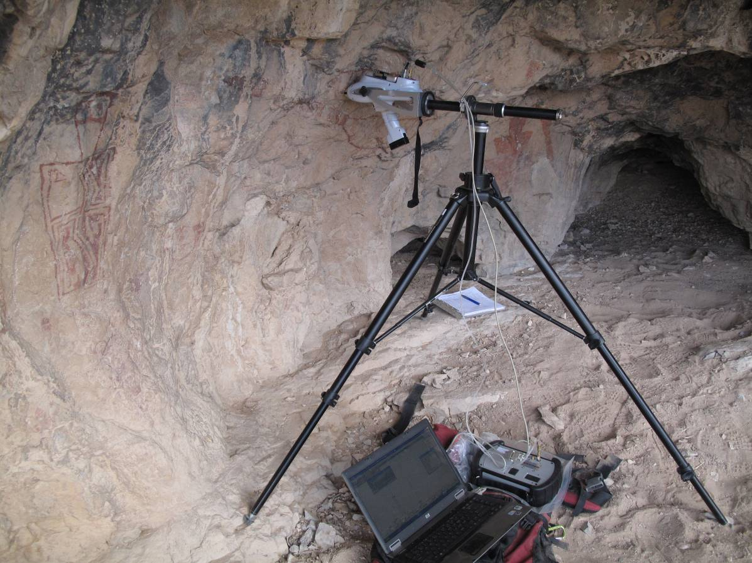
Figure 1. EDXRF data collection from Element BB at Picture Cave, Fort Bliss.

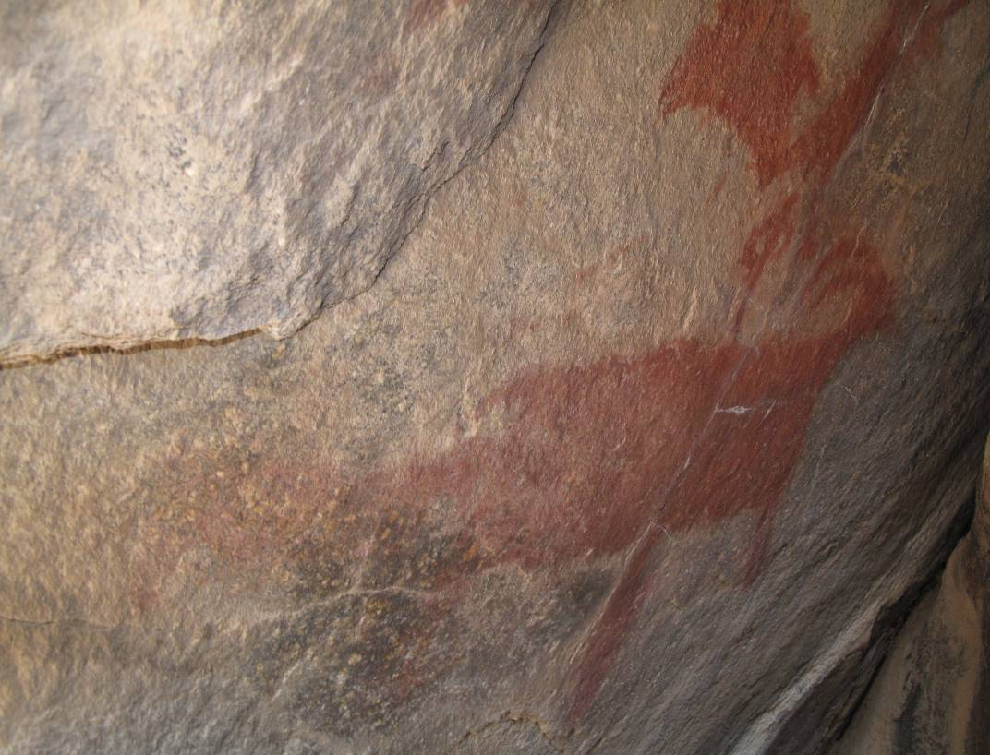
Figure 2. Pictograph Panel 2 at White Rock Shelter, Fort Bliss.
The Bruker Tracer III-V is equipped with a rhodium X-ray tube and a pelteir-cooled silicon PIN diode detector. The detector has a resolution of approximately 170 eV Full Width at Half Maximum (FWHM) for 5.9 KeV X-rays (at 1000 counts per second) in an area of 7.0 mm² (Phillips and Speakman 2009:1258). The X-ray tube generates a 4.0 mm diameter beam, which can be configured to operate at different energies, and has a user replaceable beam filter.

Two different instrument configurations that are effective for identifying elements that are common in prehistoric paints were employed in the analysis (Bruce Kaiser, personal communication 2010). Thus, when possible two separate measurements were taken for each assayed location, including painted areas and natural rock surfaces.

In the first configuration, the instrument was set to operate at 40 KeV and 12 μA. A beam filter (commonly called the “rock filter”) composed of 304 μm of aluminum (Al), 152 μm of copper (Cu), and 25 μm of titanium (Ti), was placed between the x-ray tube and the sample. The rock filter stops x-rays below 17 keV from reaching the sample thus eliminating any x-rays of that energy from being elastically or inelastically scattered by the sample into the detector. It also allows for more efficient detection of the rare earth elements (i.e., Rubidium, Strontium, Yitrium, Zirconium, and Niobium) that commonly vary among geologic deposits and are therefore frequently employed in archaeological raw material sourcing studies.

Using this configuration, elements present in the underlying rock surface to a depth of up to roughly 4 mm are also detected. Therefore, control readings from the surrounding natural rock surface were also taken. When possible a control data point in close proximity to the pigment reading was collected for each location that was sampled within the painted areas. However, as a result of time constraints it was necessary to decrease the rock surface readings, and the subsequent analyses employed grouped control readings.

In the second instrument setting the analyzer was set to operate at 15 KeV and 12 μA. A titanium beam filter was inserted, and a vacuum was employed to remove air from the device. This configuration facilitates the detection of low atomic weight elements that are the primary constituents of lithic materials (e.g., silicon, calcium). Although it is not possible to detect elements lighter than magnesium, this setting increases the sensitivity to elements between magnesium and iron on the Periodic Table. In this configuration, it is only possible to detect elements on or near the surface of the rock, which limits contamination of the pigment data by elements present in the natural underlying rock face. Depending on the thickness of the pigment, it is still possible that the atoms in the natural rock face will also be detected by the instrument. Therefore, control data points were also collected from the unmodified rock face following the procedures described above for the 40 KeV readings.

In order to analyze variation in the composition of the pigment within a given pictograph, where possible a minimum of three readings for each of the two instrument settings were collected from each analyzed element. As a result, for most elements more than 6 readings were collected per pictograph. Including the control data points, a total of up to 13 readings were collected for each analyzed pictograph. Each analysis was conducted for 150 seconds, resulting in roughly 30 minutes of EDRF data collection per analyzed pictographic element.

Data Analysis

The raw spectral data collected using two analysis settings were standardized using the inelastic (or Compton) peak of the rhodium backscatter at 19.4–22.3 KeV. These X-rays are produced by the sample scattering a small portion of the incident x-ray beam back into the detector, and are therefore theoretically constant if the specimen is “infinitely” thick (i.e., thicker than the depth that rhodium x-rays can penetrate through the natural rock matrix) and the x-ray tube produces the same number of x-rays per unit time. This procedure controls for error introduced by uneven surfaces where space exists between the rock art panel surface and the EDXRF aperture, as well as the slight variances in the x-ray beam intensity.

Data analysis included both visual examination of the raw spectral data, and statistical examination of the normalized elemental x-ray count data. Because of extreme heterogeneity in natural rock surfaces at both Picture Cave and White Rock Shelter, the x-ray count were not converted into concentrations in Parts Per Million (PPM values) for the elements present. Instead, the x-ray count data were normalized and variation within these data was analyzed. “This semi quantitative method is equally useful, and in some cases is more reliable than the quantitative method which is conventionally applied (Miksic et al. 1994:32).”

RESULTS

Because the instrument settings affect the x-ray count results, the titanium filter (15 KeV) data and the rock filter (40 KeV) data that were collected from the two sites are considered separately in the following analyses. The natural rock at Picture Cave consists of limestone, while White Rock Shelter consists of granite. These rock substrates are both highly heterogeneous, and consequently the control readings taken from areas that appeared to be unpainted are highly variable. Because of the variation in the substrates, data from the two sites are also analyzed separately in the following discussion.

PICTURE CAVE Rock filter data

This discussion focuses on the analysis of the prehistoric figures at the cave, and no further analysis of the modern paints at the sites is attempted. T-tests for Equality of Variances indicate that arsenic (Figure 2, p=0.016, equal variances not assumed), iron (Figure 3, p=0.000, equal variances not assumed), copper (Figure 4, p=0.013, equal variances not assumed), and zinc (Figure 5, p=0.003, equal variances not assumed) are significantly different in the pigment and the control sample readings taken at Picture Cave using 40KeV and the rock filter. This suggests that the pigment used to produce the pictographs contained arsenic, iron, copper, and zinc. However, as will be discussed further below, it also appears possible that the composition of the pictograph pigments varies within the site. Furthermore, it is highly probable that additional elements are present in the pigments as well, as it is impossible to detect any elements lighter than magnesium using EDXRF. In addition, the heterogeneity of the underlying rock surface may have complicated the detection of some elements that are present in both the natural rock and the pigment itself. These data suggest that the pigments continued a substantial amount of iron, which is consistent with the use of ochre based paint for the production of the pictographs at site.

Figure 3. Boxplots of arsenic x-ray pluses per analysis time (150 seconds) for control and painted locations at Picture Cave, 40KeV with rock filter.

Figure 4. Boxplots of iron x-ray pluses per analysis time (150 seconds) for control and painted locations at Picture Cave, 40KeV with rock filter.

Figure 5. Boxplots of copper x-ray pluses per analysis time (150 seconds) for control and painted locations at Picture Cave, 40KeV with rock filter.

Figure 6. Boxplots of zinc x-ray pluses per analysis time (150 seconds) for control and painted locations at Picture Cave, 40KeV with rock filter.
Variation among the pigment readings suggests the possibility that separate figures in the rock shelter were produced using different pigment mixtures. For example, Figure 7 presents boxplots for arsenic x-ray count data by rock art figure. Rock art figures on Panel 9 and Panel 1 including AA, BB, HH all have lower readings on average for arsenic suggesting these figures were made from pigments that contained less of this material. Figures CC, K, V, and Y on Panel 1 and the elements on Panel 8 all have higher x-ray count readings suggesting they may have been made from a different pigment mixture that contained more arsenic. Interestingly, elements AA, BB, and HH are all located on the right side of Panel 1, while figures K, V, and Y are all on the left side of the same panel. Figure CC is the only element from the right side of Panel 1 that has a higher arsenic value, but only two readings were taken from this figure.

Figure 7. Boxplots of arsenic x-ray pluses per analysis time (150 seconds) by prehistoric rock art element at Picture Cave (letters are for elements on Panel 1), 40KeV with rock filter.

In order to increase the sample size of readings it is useful to combine elements by the side of Panel 1. Figure 8 presents boxplots of the combined arsenic readings by side of Panel 1. The values for the left and right sides of the panel are statistically significantly different, and the T-test for Equality of Variances probability is 0.009, equal variances not assumed. With the exception of iron (p=0.005, equal variances not assumed) the readings for all of the other atoms are not significantly different for the two sides of the panel. Furthermore, the values for arsenic are not significantly different for the natural rock control readings taken on the two sides of the panel (T-test p=0.585, equal variances not assumed). This suggests the differences in the pigment readings are not exclusively the result of variation in the natural rock surface.
Figure 8. Boxplots of arsenic x-ray pluses per analysis time (150 seconds) by the side of Panel 1 at Picture Cave (excludes element CC), 40KeV with rock filter.

It is possible that the differences between the left and right sides of Panel 1 are the result of differential weathering. The elements on the left side are closer to the opening of the rock shelter, and there is evidence for differential exposure to water on the two sides of the panel. However, element CC is located on the right side and it has arsenic readings that are more similar to the left side elements, and the readings for other pigment constituents including copper and zinc are not statistically different for the two sides of the panel. Although the sample sizes are small (two readings for each panel), it also appears that the arsenic values for Panel 9 may be more similar to right side of Panel 1, while the readings for Panel 8 may be more similar to the left side of Panel 1. Panels 8 and 9 are both located along the back wall of the shelter away from the mouth, suggesting that location within the shelter alone does not determine variation in the pigment composition.

In aggregate, these data suggest that different ochre based pigments may have been used to paint the pictographs at Picture Cave. Elements AA, BB, and HH on Panel 1 and Panel 9 may have been produced from similar pigments, while CC, K, V, and Y on Panel 1 and Panel 8 may have been produced from a different paint. It is possible that these figures were executed by different artists at a given time or at different points in time. With the available data it is not possible to rule out that differential weathering or some other factor may account for the apparent differences in arsenic values at the shelter, and additional research is necessary to further test the possible variation in the paint composition within the site. The following section considers variation in the data that were collected from Picture Cave using the Ti filter and lower energy 15KeV x-rays.

PICTURE CAVE ti filter data

Of the elements detected using the Ti filter and 15 KeV x-rays at Picture Cave, only iron has statistically significant values for the pigment and control readings. The T-test for Equality of Variances for iron has a probability of 0.006 with equal variances not assumed (Figure 9). As previously observed, these data are consistent with the use of an ochre based paint at the shelter. It also appears that either stochastic variation in the background rock data have masked the presence of elements, and/or the paints used at the site did not include substantial amounts of the atoms between magnesium and manganese on the Periodic Table. It also appears that the Ti filter data are of little analytical utility for the interpretation of variation in paint composition at Picture Cave.

Figure 9. Boxplots of iron X-ray pluses per analysis time (150 seconds) for control and pigmented locations at Picture Cave, 15KeV with Ti filter.

WHITE ROCK SHELTER Rock filter data

Data were collected from five elements all located on a single petroglyph panel (Panel 2) at White Rock Cave. The highly heterogeneous nature and diversity of atoms present in the granite substrate for the pictograph panel appear to have affected the results for the 40KeV analysis, which will detect atoms up to roughly 4mm into the face of the rock. Of the atoms that were detected in the analysis, only iron and lead are significantly different in the pigment and control readings on the natural rock surface (Figures 10 and 11). The T-tests for Equality of Variances for iron and lead both have a probability of 0.001 with equal variances not assumed.

Figure 10. Boxplots of iron X-ray pluses per analysis time (150 seconds) for control and pigmented locations at White Rock Shelter, 40KeV with rock filter.

Figure 11. Boxplots of lead X-ray pluses per analysis time (150 seconds) for control and pigmented locations at White Rock Shelter, 40KeV with rock filter.

As is the case for the Picture Cave data, it is highly probable that additional elements are present in the paint. It appears that the heterogeneity of the underlying rock surface complicated the detection of elements that are present in both the natural rock and the pigment itself. The EDXRF data do suggest that the pictographs were produced from an iron oxide source that is high in lead content, and it is possible that analysis of ochre sources in the vicinity of the project area could identify the source for this pigment.

Because data were only collected from one pictograph panel at White Rock shelter it is not possible to examine variation among pictographs at the site. In addition, variation in the composition of the natural rock surfaces at Picture Cave and White Rock shelter complicate any direct comparisons of pigment composition variation between these two sites. Any comparisons are further complicated by the highly heterogeneous nature of the rock substrates at these sites. As a result, a detailed analysis of variation between the two sites is not attempted here. It is interesting to note that the pigment used to paint at least one rock art element (HH on Panel 1) at Picture Cave appeared to have high lead content. Unfortunately, the natural rock at this site also appears to include substantial amounts of lead, which complicates any direct comparison of these data. Additional research is necessary to compare the composition of the pigments used at Picture Cave and White Rock shelter.

WHITE ROCK SHELTER TI FILTER DATA

As was the case for the 15KeV data from Picture Cave, iron is the only material with a significant difference between the background control and pigment readings (Figure 12). The T-tests for Equality of Variances for the White Rock shelter iron values has a probability of 0.002 with equal variances not assumed. As previously observed, these data are consistent with the use of an ochre based paint. Again, it also appears that the paints used at the site did not include substantial amounts of the atoms between magnesium and manganese on the periodic chart, and/or stochastic variation in the background rock data have masked the presence of these elements with lower atomic weights.

Figure 12. Boxplots of Iron X-ray pluses per analysis time (150 seconds) for control and pigmented locations at White Rock Shelter, 15KeV with Ti filter.

CONCLUSIONS

This study focused on the compositional analysis of rock art pigments employed at White Rock Shelter and Picture Cave. These investigations confirmed that pigments used at both sites consisted of iron rich paints. It also appears that the paints used at the both sites did not include substantial amounts of the atoms between magnesium and manganese on the periodic chart, and/or stochastic variation in the background rock masked the presence of these elements.

Analysis of the EDXRF data also identified possible variation in the chemical composition of prehistoric paints used at Picture Cave that may be related to temporal and/or synchronic variation among the pictographs at the site. The results of the 40KeV analysis using the rock filter proved to be more analytically useful, and iron is the only light element that varied significantly between the control and pigments readings taken using 15KeV, the Ti filter, and the vacuum attached.

Analysis of the pigment employed at White Rock shelter indicates it was produced from ochre with a comparatively high lead content, and at least one figure (HH on Panel 1) at Picture Cave may have been made using similar ochre. Data from Picture Cave suggest that in addition to iron, the paint also contained copper, arsenic, and zinc. It is highly probable that the paints used at both sites also contained other constituents that were masked by atoms present in the natural rock, contamination of the panel surface by the pigments themselves, and/or or other sources of variation. Further research is necessary to better define the full range of atoms present in both the paint and natural rock. It is also possible the analysis of ochre samples from source location could provide insight for identifying the procurement areas for the pigments used at the two sites.

Spectral data collected from Picture Cave suggest the possibility that the largest figures on the right side of Panel 1 and Panel 9 may have been created using one type of paint that contained comparatively little arsenic. The largest figures on the left side of Panel 1 and Panel 8 may possibly have been produced from a different paint mixture that included more arsenic. Additional data, including further characterization of the natural rock surfaces and pigmented areas are necessary to evaluate this possible variation that was identified in this analysis.

Several changes to the methodology employed in the study are recommended if additional EDXRF research is undertaken at Fort Bliss. First, this study demonstrated that the Ti filter data are of limited heuristic value, and it is recommended that no additional data are collected for light atoms using the Ti filter and lower energy x-rays. Second, although less accurate it is recommended that the analysis time is reduced from 150 seconds in order to allow the collection of more data points. Third, sampling at systematic intervals along a grid that includes both pigmented areas and natural rock surfaces would facilitate analysis of variation in the pigment composition. Furthermore, systematically collected data would also allow evaluation of any contamination of the surrounding rock surfaces by weathering, capillary action from the pigments, and/or other sources of variation in these data. Fourth, it is recommended that any additional research should include the collection of control samples from pigment sources in the vicinity of the project area. Compositional data from sources would both facilitate the identification of constituents present in the pictographs, and it would also potentially allow identification of source locations for the paints that were used to make the rock art.

REFERENCES

Jercher, M., A Pring, P.G. Jones, and M. D. Raven
1998 Rietveld X-ray Diffraction and X-ray Fluorescence Analysis of Australian Aboriginal Ochres. Archaeometry 40 (2) 282-401.

Iriarte, E., A. Foyo, M. A. Sanchez, and C. Tomillo
2007 The Origin and Geochemical Characterization of Red Ochres from the Tito Bustillo and Monte Castillo Caves (northern Spain). Archaeometry 51(2): 231-251.

Miksic, J. N., C. T. Yap, and H. Younan
1994 Archaeology and Early Chinese Glass Trade in Southeast Asia. Journal of Southeast Asian Studies 25(1):31-46.

Roldan, Clodoaldo, Sonia Murcia-Mascaros, Jose Ferreo, Valentine Villaverde, Esther Lopez, Ines Domingo, Rafal Martinez and Pere Miquel Guillem.
2010 Application of Field Portable EDXRF Spectrometry to analysis of pigments of Levantine rock art. X-Ray Spectrometry 39: 243-250.

Loendorf, Lawrence L.
1994 Finnegan Cave: A Rock Art Vision Quest Site on Montana. in Shamanism and Rock Art in North America, Solveig A. Turpin, ed. Rock Art Foundation, Inc. Special Publication, (1):125-137, Rock Art Foundation, Inc. , San Antonio, Texas.

Newman, Bonita and Loendorf, Larry
2005 Portable X-Ray Fluorescence Analysis of Rock Art Pigments. Plains Anthropologist, Vol. 50(195):277-283, Plains Anthropological Society , Lincoln, Nebraska.

